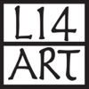

Addendum to 2024 Local 14 Consignment Agreement

I’m providing inventory sheets.

I’m not providing inventory sheets. I understand that by not providing this list I forfeit my right to be covered by Local 14 insurance in case of theft or damage.

Artist Name (print):________________________________________________

Artist Signature:___________________________________________________

Date:_____________________________________________________________