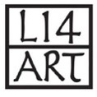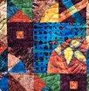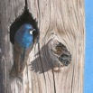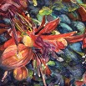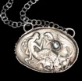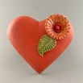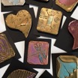

**Local 14 Art Show & Sale • October 4, 5, & 6 • Miller Hall, World Forestry Center**

**DIRECTORS WELCOME TO OUR GUESTS**

Welcome to the **57th** year of Local 14’s Art Show and Sale on October 4th, October 5th, and 6th at the World Forestry Center. Our show season begins with our Kick-Off Dinner on **Tuesday September 3rd**. At that time, we will be honoring our scholarship winners and sharing the information you will need for successful participation in the show.

**Important Dates and Times:**

**Local 14 Hosted Kick-off Dinner:** **Tuesday**, September 3rd at6:00 pm

**Location:** Lakewood Center for the Arts

368 S State St, Lake Oswego, OR

**Show Set-up:** **Thursday**, October 3rd, 9am – 8pm

**Show:** **Friday**, October 4th, 10am – 6pm

**Saturday**, October 5th, 10am – 6pm

**Sunday**, October 6th, 10am – 4pm

**Publicity and Social Media:**

Postcards will be available for pickup at the Kick-off dinner to distribute to your patrons. Among the guest artist documents on our website, a .pdf and .jpg version of our postcard will be available to download for your promotional purposes. Feel free to engage with Local 14’s Facebook and Instagram sites. If you haven’t already, please send your social media links to us if you wish to be promoted by Local 14. The links for our social media accounts are:

https://www.facebook.com/Local14Artshow/

https://www.instagram.com/l14artshow/

**Show Packet:**

Your Show Packet is available to download via our website: [www.local14.org](http://www.local14.org).

**Work Hours & Load-In:**

You will be sent a link via email to sign up for your show work hours. Your booth location information and load in/out instructions will also be emailed. We look forward to working with each of you and thank you for your energy, enthusiasm, and talent that you bring to our show! Please contact us if you have any questions.

**Contacts:**

**Director:** Terri Neal, [ferg2neal@gmail.com](mailto:ferg2neal@gmail.com) , 503-750-7757

**Guest Artist Liaison**: Janis Childs, Liz Casale [Local14GuestArtistLiaison@gmail.com](mailto:Local14GuestArtistLiaison@gmail.com)

**Jewelers Liaison:** Carli Schultz [glass@juiceglass.com](mailto:glass@juiceglass.com)

**Layout:** Mitzi Kugler [mitzikart@gmail.com](mailto:mitzikart@gmail.com), Greta Schneider coppercreekdesigns@yahoo.com